|  |  |
| --- | --- |
| **NAME** | **PRASANTHKUMAR G** |
| **REG NO** | **611819106036** |
| **TOPIC** | ***ASSIGNMENT ON MAKE A SMART HOME USING TINKERCAD*** |
| **PROJECT TITLE** | **REAL TIME RIVER WATER QUALITY MONITORING AND CONTROL SYSTEM** |
| **ASSIGNMENT NO** | **01** |
| **MENTOR** | **PRAKASAM L ASP/ECE** |
| **COLLEGE NAME** | **P.S.V. COLLEGE OF ENGINEERING AND TECHNOLOGY** |

**MAKE A SMART HOME**

# Tinkercad link:

**[https://www.tinkercad.com/things/00vvlIJaQmU-mighty-](https://www.tinkercad.com/things/00vvlIJaQmU-mighty-curcan/editel?sharecode=eRVtvg20wQPV_Ry3tj-i6dVNqyy2m-7pb0iM_zG6gOo) [curcan/editel?sharecode=eRVtvg20wQPV_Ry3tj-i6dVNqyy2m-7pb0iM_zG6gOo](https://www.tinkercad.com/things/00vvlIJaQmU-mighty-curcan/editel?sharecode=eRVtvg20wQPV_Ry3tj-i6dVNqyy2m-7pb0iM_zG6gOo)**

# Circuit design:

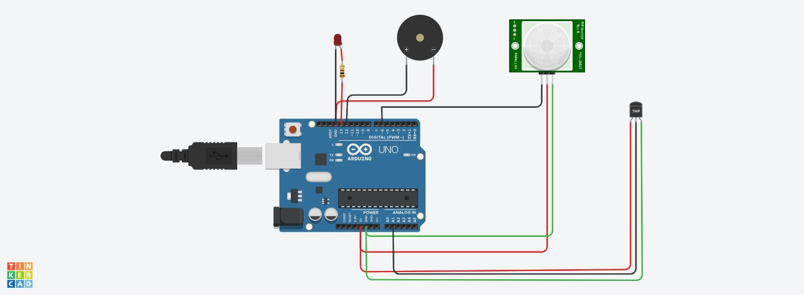

**Component Required:**

Name Quantity Component

|  |  |  |
| --- | --- | --- |
| U1 | 1 | Arduino Uno R3 |
| D1 | 1 | Red LED |
| PIR1 | 1 | -52.66 , -315.7896985209941 , -337.33 PIR Sensor |
| PIEZO1 | 1 | Piezo |
| U2 | 1 | Temperature Sensor [TMP36] |
| R1 | 1 | 100 Ω Resistor |

# Code:

float temp; void setup()

{

pinMode (6,INPUT); pinMode (12,OUTPUT);

Serial.begin(9600);

}

void loop()

{

if (digitalRead(6)==HIGH)

{

tone(12,523,1000);

Serial.println("Unknown detected");

{

int ledPin=13;

{

pinMode(ledPin,OUTPUT);

}

digitalWrite(ledPin,HIGH); delay(1000); digitalWrite(ledPin,LOW); delay(1000);

}

}

else

{

noTone(12);

}

temp=analogRead(A1); temp=temp*0.48828125;

if(temp>=110.84)

{

tone (12,100,2000);

Serial.print("Above 60 c Temperature...");

{

int ledPin=13;

{

pinMode(ledPin,OUTPUT);

}

digitalWrite(ledPin,HIGH); delay(1000); digitalWrite(ledPin,LOW); delay(1000);

}

}

else

{

noTone(12);

}

}/